The basic statistical description of the yield of the SME board index

We start with the study yield rate sequence.

This is the log return of SEM board index.

Figure 1

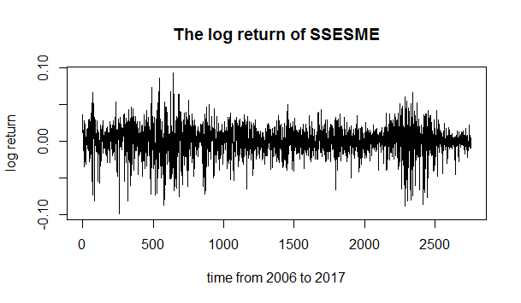

It can be seen that the volatility of the yield sequence has a significant aggregation and the yield is essentially zero.

We examined the ACF and PACF of the yield series.

Figure 2

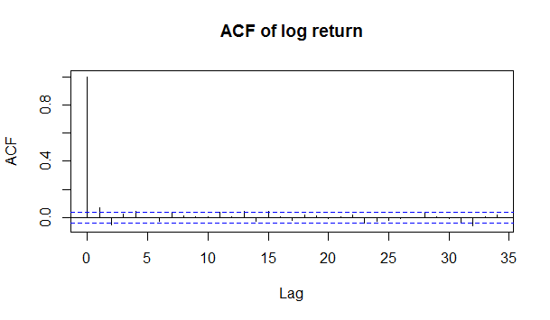

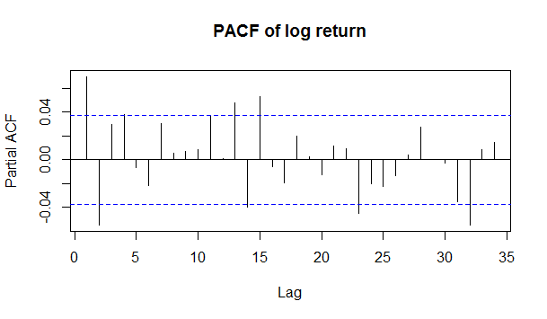

We can know that the rate of return has a self-correlation.

Then we draw the absolute yield of the ACF and PACF.

Figure 3

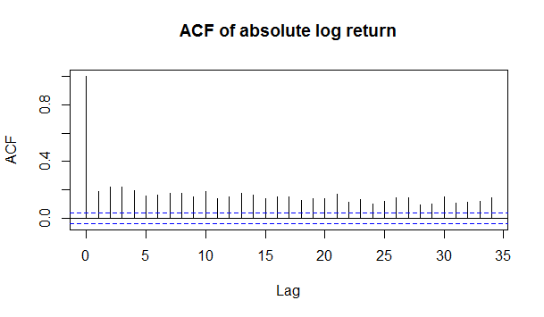

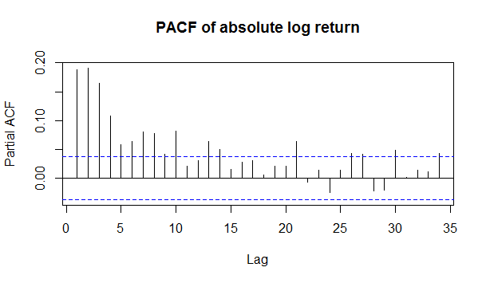

Draw the squared yield of the ACF and PACF.

Figure 4

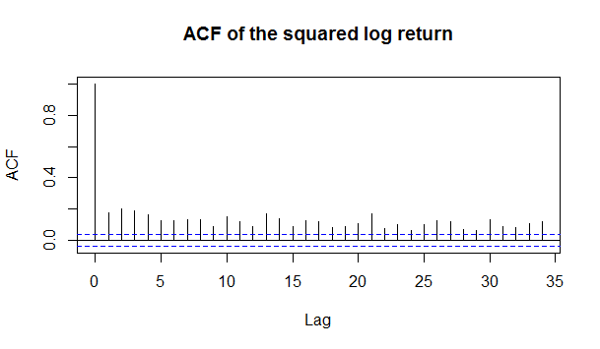

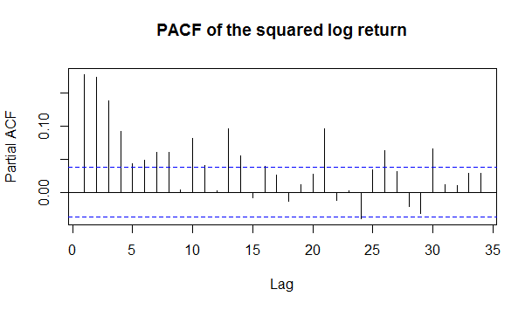

We can see that the absolute value of the yield and the sequence after the square show a significant sequence dependency. This also indicates that the possible yield sequence exists in the ARCH effect, which we will discuss next.

ARCH and GARCH model

We tested LM for the yield sequence to determine if there was an ARCH effect. For this purpose, choose to lag 4, 8, 12 order to calculate, the results are as follows:

Table 1 LM test of SSESME

|  |  |  |  |
| --- | --- | --- | --- |
|  | Lag 4 | Lag 8 | Lag 12 |
| Chi-squared | 237.06 | 265.06 | 285.64 |
| p-value | < 2.2e-16 | < 2.2e-16 | < 2.2e-16 |

According to Table 1, P value is less than 2.2e-16, Reject the original hypothesis, It is further proved that the yield sequence exists ARCH effect.

Here we explore the order problem of ARCH or GARCH, as follows: First, the ARMA model is established for the conditional mean, and then the GARCH model is further studied by the result of the residual sequence of the ARMA model.

Establish conditional mean ARMA model. We establish the ARMA (0,0), ARMA (1,0), ARMA (0,1), ARMA (1,1) models for the conditional mean values. The four AIC values are:

Table 2 AIC value of ARMA

|  |  |  |  |  |
| --- | --- | --- | --- | --- |
|  | ARMA (0,0) | ARMA (1,0) | ARMA (0,1) | ARMA (1,1) |
| AIC | 13751.62 | 13764.75 | 13763.11 | 13768.63 |

It can be seen that the AIC value of ARMA (0,0) is the smallest, so the conditional mean should be ARMA (0,0) model.

Then we establish the GARCH model. We first determine the order of the GARCH model, describe the stock return sequence with the ARMA (0,0) + GARCH (p, q) model, where p and q are 1 to 3, and the appropriate model is selected according to the AIC value. The results are as follows:

Table 3 AIC value of GARCH

|  |  |  |  |
| --- | --- | --- | --- |
| model | GARCH(1,1) | GARCH(1,2) | GARCH(1,3) |
| AIC | -5.209770 | -5.209314 | -5.208767 |
| model | GARCH(2,1) | GARCH(2,2) | GARCH(2,3) |
| AIC | -5.209183 | -5.208588 | -5.208046 |
| model | GARCH(3,1) | GARCH(3,2) | GARCH(3,3) |
| AIC | -5.208428 | -5.207832 | -5.207320 |

According to the results in Table 3, we can see that for the small plate yield data, the AIC value of the GARCH model is -5,209770, which is the smallest, so the GARCH (1,1) model is selected.

And this is the Standardized Residuals Tests of GARCH (1, 1) model:

Table 4 Standardized Residuals Tests

|  |  |  |  |  |
| --- | --- | --- | --- | --- |
|  |  |  | Statistic | p-Value |
| Jarque-Bera Test | R | Chi^2 | 464.9117 | 0 |
| Shapiro-Wilk Test | R | w | 0.9767459 | 0 |
| Ljung-Box Test | R | Q(10) | 26.97139 | 0.002631614 |
| Ljung-Box Test | R | Q(15) | 36.26838 | 0.001616782 |
| Ljung-Box Test | R | Q(20) | 40.02091 | 0.004965101 |
| Ljung-Box Test | R^2 | Q(10) | 6.107173 | 0.8061801 |
| Ljung-Box Test | R^2 | Q(15) | 9.77121 | 0.8338793 |
| Ljung-Box Test | R^2 | Q(20) | 11.07668 | 0.9442096 |
| LM Arch Test | R | TR^2 | 8.004575 | 0.7847728 |

Table 5 Information Criterion Statistics:

|  |  |  |  |
| --- | --- | --- | --- |
| AIC | BIC | SIC | HQIC |
| -5.209770 | -5.201173 | -5.209774 | -5.206664 |

So, GARCH(1,1) model is appropriate for SME board.

Estimate the parameters of GARCH（1，1）,here is the result:

Table 6 Parameters of GARCH（1，1）

|  |  |  |  |  |
| --- | --- | --- | --- | --- |
|  | Estimate | Std. Error | t value | Pr(>|t|) |
| Mu | 1.923e-04 | 3.017e-04 | 0.637 | 0.52381 |
| Omega | 2.542e-06 | 7.738e-07 | 3.285 | 0.00102 ** |
| Alpha1 | 5.508e-02 | 6.837e-03 | 8.056 | 8.88e-16 *** |
| Beta1 | 9.388e-01 | 7.507e-03 | 125.060 | < 2e-16 *** |

Signif. codes: 0 ‘***’ 0.001 ‘**’ 0.01 ‘*’ 0.05 ‘.’ 0.1 ‘ ’ 1.

We can get that the sum of the parameters of the CARCH model is equal to α+β=5.508e-02+9.388e-01=0.9896.The sum is larger than 0.95, indicating that SME board have strong fluctuations in aggregation and sustainability.